|  |  |  |  |
| --- | --- | --- | --- |
| UMass-Lowell-logo.png (295×358) | **Lab #6** | **CIRCUIT or ELECTRONICS** | |
|  |  | |
| Keegan Smith | | |
| Bench 19 | | |
| EECE –3110.804A  Circuits or Electronics Lab 6 | | |
| Date submitted: 4/18/2022 | | |
| Due date: 5/2/2022 | |  |

I. SUMMARY

N/A

II. EQUIPMENT

Table 1 talks about the equipment including their make, model, and serial number. Table 2 is the list of the smaller parts along with their details.

**Table 1. Equipment Used**

|  |  |  |
| --- | --- | --- |
| **Equipment Type** | **Details** | |
| * Oscilloscope | *Make:* | InfiniiVision |
| *Model:* | DSO-X2004A |
| *Serial Number:* | MY52161432 |
| * Digital Multimeter | *Make:* | Keithley |
| *Model:* | 2110 5½ |
| *Serial Number:* | 8004026 |
| * DC Power Supply | *Make:* | GWInstek |
| *Model:* | GPD-3303D |
| *Serial Number:* | EM840514 |
| * Function Generator | *Make:* | Tektronix |
| *Model:* | AFG1022 |
| *Serial Number:* | AFG102217331728 |
| * Analog Discovery | *Make:* | Digilent |
| *Model:* | Analog Discovery 2 |
| *Serial Number:* | 210231B0DF82 |
| * Breadboard * Bench “Shoebox” with connector cables, adapters, clips etc. | N/A | |

III. INTRODUCTION

N/A

IV. CIRCUIT DESCRIPTION

Pictures and videos only

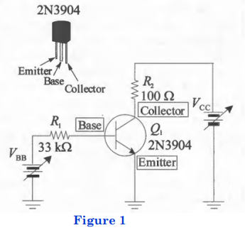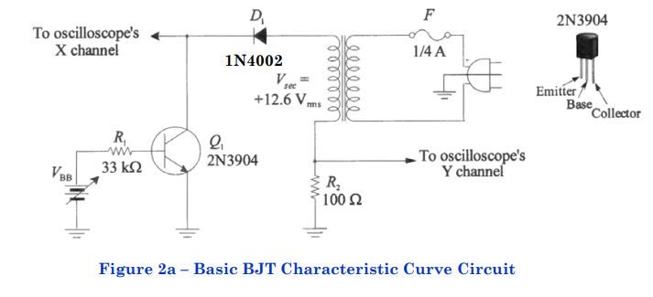

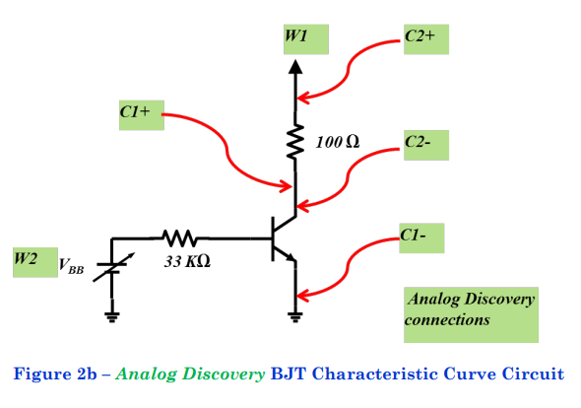

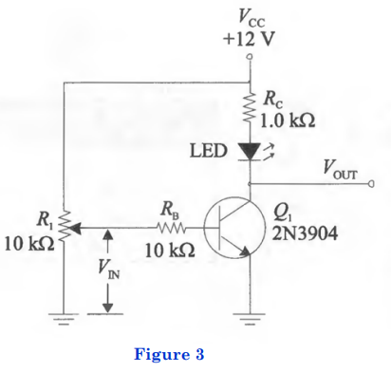

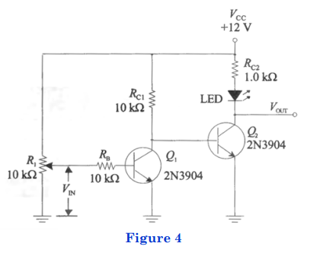

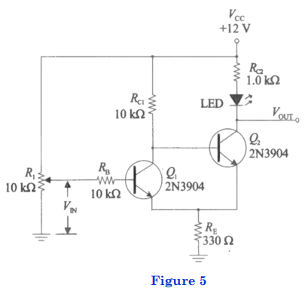

V. MEASUREMENTS

Tables and Screenshots only

Table 1. Resistor Values

|  |  |  |
| --- | --- | --- |
| Resistor | Nominal Value | Measured Value |
| R1 | 33kΩ | 31.94kΩ |
| R2 | 100Ω | 98.1lΩ |

Table 2. VR2­ and I­C­ Measurements and Calculations

|  |  |  |  |  |  |  |
| --- | --- | --- | --- | --- | --- | --- |
| VCE  (measured) | IB = 50µA | | IB = 100µA | | IB = 150µA | |
| VR2 (measured) | IC **  (calculated) | VR2 (measured) | IC **  (calculated) | VR2 (measured) | IC **  (calculated) |
| 2.0v | 252mV | 2.568mA | 2.885V | 29.4087mA | 4.759V | 48.511mA |
| 4.0V | -1.693V | -17.257mA | 557mV | 5.6778mA | 3.741V | 38.134mA |
| 6.0V | -3.640V | -37.142mA | -1.357V | -13.832mA | 725mV | 7.3904mA |
| 8.0V | -5.591V | -56.992mA | -3.243V | -33.058mA | -1.157V | -11.794mA |

**Values depend on measured value, could not be calculated during pre-lab

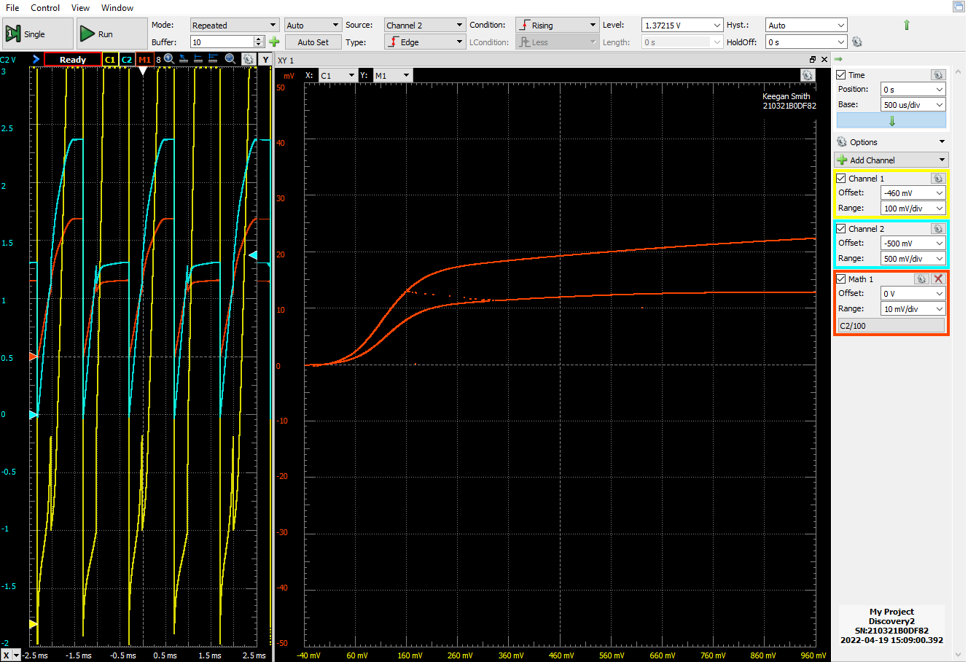Figure 6. Characteristic Curve plotted using X-Y mode on Oscilloscope

Table 3. Current Gain Calculations

|  |  |  |  |
| --- | --- | --- | --- |
|  | Current Gain, βDC | | |
| VCE | IB = 50µA | IB = 100µA | IB = 150µA |
| 3.0v |  |  |  |
| 5.0v |  |  |  |

Table 4. Resistor Value

|  |  |  |
| --- | --- | --- |
| Resistor | Nominal Value | Measured Value |
| RB | 10kΩ | 9.835kΩ |
| RC | 1.0kΩ | 976.94kΩ |
| RC1 | 10kΩ | 9.8569kΩ |
| RE | 330Ω | 325Ω |

Table 5. Cut-Off and Saturation Voltages and ISAT

|  |  |  |
| --- | --- | --- |
| Quantity | Computed Value | Measured Value |
| V­CE(cut-off) | 5v | 10.64V |
| V­CE(sat) | 0.1v | 29.9mV |
| V­RC(cut-off) | 1.9v | 4.57V |
| I­SAT | 10.521mA |  |

Table 6. VIN and VOUT Measured Values

|  |  |
| --- | --- |
| Quantity | Measured Value |
| V­IN (LED on) | -2mV |
| V­OUT (LED on) | 35mV |
| V­IN (Threshold) | 720mV |
| V­OUT (Threshold) | 10.545V |

Table 7. VIN and V­OUT LED on, Lower and Upper Threshold Voltages

|  |  |
| --- | --- |
| Quantity | Measured Value |
| V­IN (LED on) | -1mV |
| V­OUT (LED on) | 3.391V |
| V­IN (upper threshold) | 2.679V |
| V­OUT (upper threshold) | 10.548V |
| V­IN (lower threshold) | 1.041V |
| V­OUT (lower threshold) | 2.394V |

Figure 7. Transfer Curve of BJT Switching Circuit

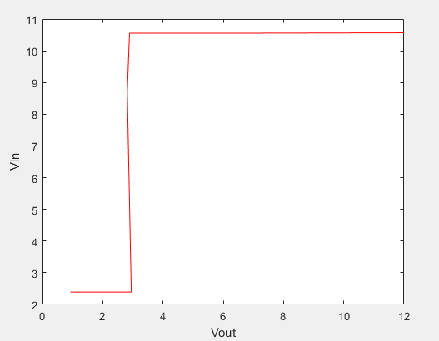

VI.

DISCUSSION

I had no issues with performing this lab

VII. CONLUSION

N/A

VIII. QUESTIONS

N/A

REFERENCES

1. Lab Report: Boylestad, R. L.. (2007). Laboratory Manual to Accompany Introductory Circuit Analysis. (11th ed.). Pearson, NJ
2. Juniette Fifield Lab report Super Condensed 6